30.AIM:-: To draw UML diagram for train reservation system using umbrello.

ACTIVITY DIAGRAM:

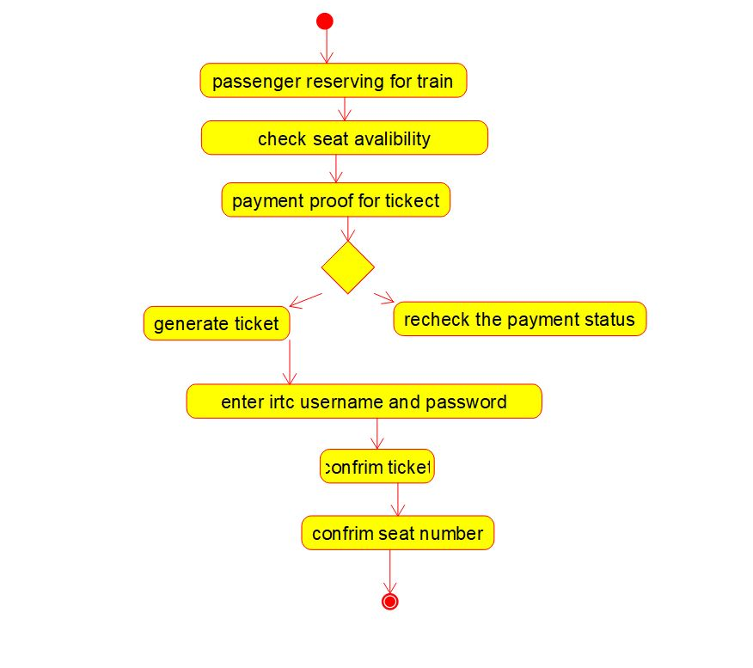

USE CASE DIAGRAM:

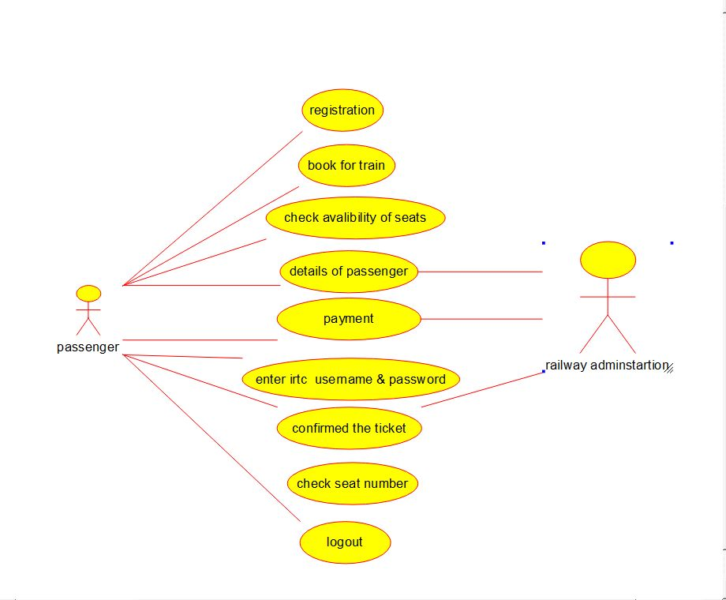

COMPONENT DIAGRAM:

